|  |  |  |  |  |  |  |  |  |  |  |  |  |  |  |  |  |  |  |  |
| --- | --- | --- | --- | --- | --- | --- | --- | --- | --- | --- | --- | --- | --- | --- | --- | --- | --- | --- | --- |
| |  |  | | --- | --- | | **Model** |  | | **Manufacturer** |  | | **Supplier** |  | | **Category** |  | | **Crop(s)** |  | | **Website/Link** |  | | **E-mail** |  | | **Phone Number** |  | | **Address** |  | |  |

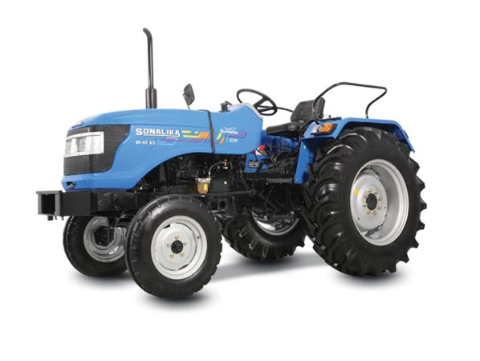

**Specifications**

|  |  |
| --- | --- |
| **Item** | **Value** |
|  |  |
|  |  |
|  |  |
|  |  |
|  |  |
|  |  |
|  |  |
|  |  |
|  |  |
|  |  |
|  |  |
|  |  |
|  |  |
|  |  |
|  |  |
|  |  |
|  |  |
|  |  |
|  |  |
|  |  |
|  |  |
|  |  |
|  |  |
|  |  |
|  |  |
|  |  |
|  |  |
|  |  |
|  |  |
|  |  |
|  |  |
|  |  |
|  |  |
|  |  |
|  |  |
|  |  |
|  |  |
|  |  |
|  |  |
|  |  |
|  |  |
|  |  |
|  |  |
|  |  |
|  |  |
|  |  |
|  |  |
|  |  |
|  |  |
|  |  |
|  |  |
|  |  |
|  |  |
|  |  |
|  |  |
|  |  |
|  |  |
|  |  |